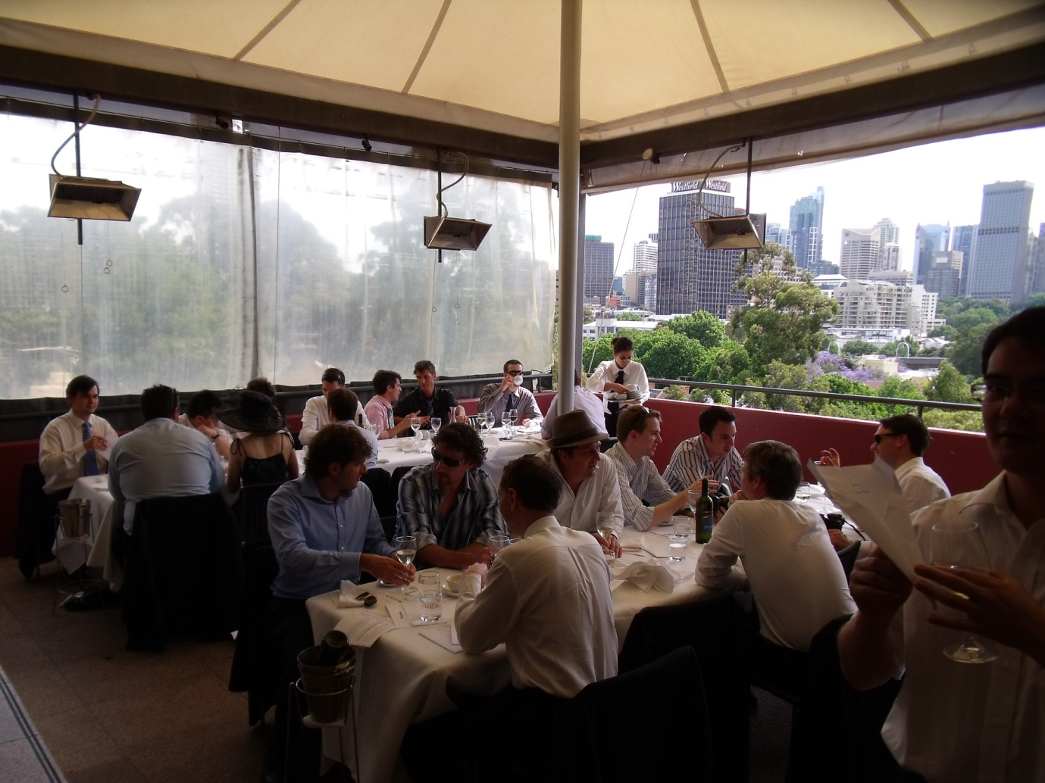



Search the ABC

- News
  - Just In
  - Australia
  - World
  - Business
  - Sport
  - Entertainment
  - Weather
  - Opinion
  - Blogs
  - Elections
- Weather
  - NSW/ACT
  - VIC
  - QLD
  - WA
  - SA
  - TAS
  - NT
  - International Weather
- Sport
  - Grandstand Sport Home
  - Cricket
  - AFL
  - Rugby League
  - Rugby Union
  - Football
  - Tennis
  - Golf
  - More Sports
- Radio
  - Radio National
  - Local Radio
  - Classic FM
  - triple j
  - NewsRadio
  - Radio Australia
  - dig
  - Listen Online
  - Digital Radio
  - Find your frequency
- TV
  - TV Guide
  - Video
  - Program Websites
  - ABC1
  - ABC2
  - TV: Have Your Say
- iView
- Kids
  - Playground
  - Rollercoaster
  - Parenting
  - Rollercoaster Games
  - ABC Kids TV Guide
- Health
  - Health News
  - The Pulse
  - Topics A-Z
  - Talking Health
  - Quizzes & Tools
  - Healthy Recipes
- Science
  - News in Science
  - Topics
  - In Depth
  - Dr Karl
  - Ask an Expert
  - Quizzes & Games
  - Science Careers
  - Teaching Science
- International
  - Australia Network TV
  - Radio Australia
  - Chinese
  - French
  - Indonesian
  - Khmer
  - Tok Pisin
  - Vietnamese
- ABC Shop
  - DVD
  - Books
  - Music
  - Magazines
  - Clothing
  - Toys & Novelties
  - New Releases (1)
  - Best Sellers (1)
  - Downloads
- More...
  - ABC Commercial
  - Arts & Entertainment
  - Best of ABC
  - Education
  - Indigenous
  - Local
  - Religion & Ethics
  - Rural
  - Services
  - Unleashed
  - Site Map

News
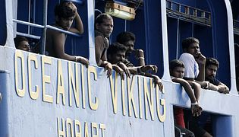

Oceanic Viking standoff ends
Updated: 17 November 2009. 16:47:43 (AEDT)
Indonesian officials say the stand-off with the remaining asylum seekers aboard the Oceanic Viking is over. >more
Just In | Australia | World | Business | Entertainment | Opinion | Sport

TV
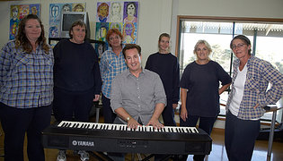

Jail Birds
Tuesday 8.00pm
Following on from the success of the award-winning ABC television series Choir Of Hard Knocks, choirmaster Jonathon Welch is on a mission.
TV Guide | Video | Program Websites | ABC1 | ABC2

Best of abc.net.au – Our picks of unmissable content

Batchelor goes the full monty
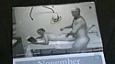
The everyday folk from this Northern Territory town get naked for a good cause.
- Watch (3 MB)
- More - ABC News Video

One man mending fences
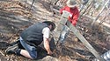
BlazeAid volunteers have replaced 500km of fencing destroyed by Black Saturday.
- Listen (4'22")
- Download - RN Breakfast

Addicted To Money

The financial industry established what was in effect a drug ring, pushing easy credit.
- Watch (8 MB)
- Broadband Special
- Also on iView

Hot chips

Australia's fastest computer - nicknamed the Vayu - will be used for climate change research.
- Listen (3'11")
- Download - PM

Unleashed: Candid opinion and response
Poll: Do you plan to cut spending this Christmas?


Crude reasoning
Some Australians have displayed incredulous gullibility in accepting the Tigers' tall tales as fact. >more 'Crude reasoning'


Wars of choice
General Peter Cosgrove considers issues of national interest and security. >more 'Wars of choice'


Tense talks
Japan and the US are in tense talks over the future of an American military base in Okinawa. >more 'Tense talks'
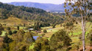

Damned decision
Peter Garrett has put the needs of fish and turtles ahead of the water needs of Queenslanders. >more 'Damned decision'

Kids & Parenting


Play School
Come into the Play School website and play games with Big Ted, Little Ted, Humpty and Jemima and see all the other toys and personalities. You will also find recipies and things to make and do. >more 'Play School'
Playground | Rollercoaster | Parenting | Rollercoaster Games | ABC Kids TV Guide

Grandstand Sport
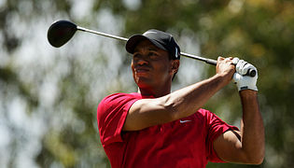

Interview: Tiger Woods
World number one Tiger Woods says he will not rule out returning to Kingston Heath next year to defend his Australian Masters Title. >more 'Interview: Tiger Woods'
Cricket | AFL | League | Union | Football | More Sports

Health | Science
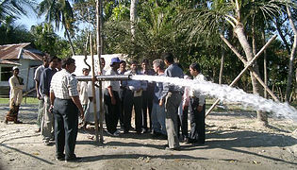

Mass arsenic poisoning mystery solved
Researchers have finally worked out what led to the widespread release of arsenic into drinking water in rural Bangladesh, affecting millions of people.> more 'Mass arsenic poisoning mystery solved'
News in Science | Topics | Health News | Health Topics

Featured Sites
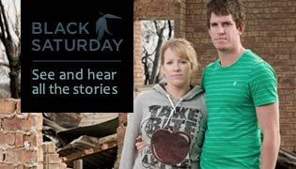

Black Saturday
On February 7 2009, Victoria experienced the worst bushfires in the nation's recorded history. This website tells the story of the fires and their aftermath, placing personal stories alongside information about key events which you explore using a map and a timeline.>more 'Black Saturday'

Radio
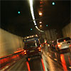

Cars: the crunch!
Driving is 'like living a nightmare in a mad computer game'. A Science Show special. >more Cars: the crunch!

ABC Radio National | Listen to Radio National | Radio National Podcast
ABC NewsRadio | Listen to NewsRadio | NewsRadio Podcast
ABC Classic FM | Listen to Classic FM | Classic FM Podcast
triple j | Listen to triple j | triple j Podcast
dig | Listen to dig | dig Podcast
Radio Australia | Listen to Radio Australia | Radio Australia Podcast

ABC Local
Set your location for local radio, news, weather and community

Select Location

ABC Shop


Wuthering Heights
Wuthering Heights remains one of the most haunting romances in english literature and this sumptuous version beautifully captures its dark,compelling essence.
New Releases | Best Sellers | Specials

NoticeBoard

Mobile Survey

Give us your feedback on the mobile web.


Services

ABC iView
Full-screen video service

Mobiles / PDAs
ABC content for your mobile or PDA

Podcasting
Download ABC audio

Video podcasting
Download ABC TV video

ABC Widgets
Take your ABC with you

RSS / XML Feeds
Receive constant updates

Mailing lists
Subscribe to newsletters and email alerts

Download ABC Now and receive constant updates

Latest Transcripts
- Fire at Pilliga
ABC New England North West NSW
- Inverell Fire on Thunderbolts Way
ABC New England North West NSW
- Angus Emmott
ABC Queensland Conversations
- A crate idea: the search for Shackleton's stash
The World Today
- Study shows vitamin D may slow MS progress
The World Today
- Remembering where Wonthaggi's heart started beating
ABC Gippsland Vic
- Survey finds news online audience ready to pay
The World Today
- Committee calls for more funds for remote stores
The World Today
- More transcripts...

Explore the ABC
- ABC Commercial
  - Buy TV Programs
  - Stock Footage
  - Online/Mobile
  - Educational
  - Music Publishing
  - Live Events
- ABC Shop
  - DVD
  - Books
  - Music
  - Magazines
  - Clothing
  - Toys & Novelties
  - New Releases (2)
  - Best Sellers (2)
  - Downloads
- Arts
  - Arts: Blog
  - Arts News
  - Arts: Events
  - Arts: Reviews
  - New Work
  - Arts: TV & Radio
  - Arts: Video
  - Arts: Audio
  - Arts Genres
  - Arts: Have Your Say
  - Arts Links
- Best of ABC online
- Education
  - Schools TV
  - For Schools
  - Education Topics
  - Lifelong Learning
- Featured sites
  - Black Saturday
  - The Big Diary
  - Gallipoli in 3D
  - ABC Mobile
  - Sydney Sidetracks
  - ABC Earth
- Health & Wellbeing
  - Health News
  - The Pulse
  - Topics A-Z
  - Talking Health
  - Quizzes & Tools
  - Healthy Recipes
  - Health Minutes
  - Healthy Living
- Indigenous
  - Indigenous News
  - Language Map
  - Local Heroes
  - Your Voice
  - Arts & Events
  - Health & Recipes
  - Message Stick TV
  - Speaking Out
  - Awaye!
- International
  - Australia Network TV
  - Radio Australia
  - Chinese
  - French
  - Indonesian
  - Khmer
  - Tok Pisin
  - Vietnamese
- Kids & Parenting
  - Playground
  - Rollercoaster
  - Parenting
  - Rollercoaster Games
  - ABC Kids TV Guide
- Local
  - Grandstand Sport
  - Rural
  - Local Podcasts
  - Special sites
  - Recipes
  - Local Arts
- News
  - Just In
  - Australia
  - World
  - Business
  - Sport
  - Entertainment
  - Weather
  - Opinion
  - Blogs
  - News Video
  - News Audio
  - Podcasts/RSS
  - Email
  - Contribute
  - Tags
  - Elections
- Radio
  - Radio National
  - Local Radio
  - Classic FM
  - triple j
  - NewsRadio
  - Radio Australia
  - dig
  - Listen Online
  - Digital Radio
  - Find your frequency
- Religion & Ethics
  - The Ark
  - Encounter
  - For The God Who Sings
  - The Religion Report
  - The Rhythm Divine
  - The Spirit of Things
  - Sunday Nights
  - Compass
  - Songs of Praise, and Hymns of Glory
- Resource Sales
  - Costumes
  - Minicam
  - Outside Broadcast
  - Production Services
  - Studios
  - Venue Hire
- Rural
  - Rural News
  - Rural Programs
  - Rural Features
  - Message Boards
  - Rural Blog
  - Country Breakfast
  - Rural Reporter
  - Landline
- Science
  - News in Science
  - Topics
  - In Depth
  - Dr Karl
  - Ask an Expert
  - Quizzes & Games
  - Science Careers
  - Teaching Science
  - Science Video
  - Science Audio
  - Science Photos
  - Ancient Worlds
  - Being Human
  - Energy & Transport
  - Environment & Nature
  - Health & Medical
  - Innovation & technology
  - Space & Astronomy
- Services
  - ABC Now
  - RSS / XML Feeds
  - Video podcasting
  - Podcasting
  - Mobiles / PDAs
  - Disaster information
  - Mailing lists
- Sport
  - Grandstand Sport Home
  - Cricket
  - AFL
  - Rugby League
  - Rugby Union
  - Football
  - Tennis
  - Golf
  - More Sports
- TV
  - TV Guide
  - Video
  - Program Websites
  - ABC1
  - ABC2
  - iView
  - TV: Have Your Say
- Unleashed
- Weather
  - NSW/ACT
  - VIC
  - QLD
  - WA
  - SA
  - TAS
  - NT
  - International Weather

There is a lower-bandwidth version of this page available here
Careers | ABC Services | Help | About the ABC | Contact the ABC | Sitemap | Feedback and FAQs
© 2009 ABC | Privacy Policy | Conditions of Use

